HisabDo
Next-Phase AI Roadmap
Consolidated AI Development Documentation
Day 15–20 Review & Day 21+ Plan
Prepared by: Omesh Lakhani
AI/ML Team | HisabDo Internship Projects
August 2026

📌 Purpose

This document consolidates all AI/ML work from Days 15–20 and defines a structured next-phase development plan for the HisabDo application. It covers the earlier AI feasibility research, RAG planning, AI Content Recommendations, FAQ Assistant, Chatbot, Multilingual Support, Financial AI, Smart Insights, User Engagement, milestones, ownership, dependencies, testing, GitHub workflow, and long-term scalability.
Status Rule: A feature is marked Planned unless previous work clearly confirmed its implementation. This avoids claiming that an unverified module is already complete.

1. Review of Previous AI Work

• AI Feasibility Research: technical feasibility, AI model research, Ollama feasibility, RAG feasibility, FastAPI integration, offline-first possibilities and cost considerations.
• AI Content Recommendations: personalized content suggestions, related-content recommendations and user-behavior-based recommendations.
• Next-Phase AI Roadmap: RAG, FAQ Assistant, chatbot, multilingual support, Financial AI, Smart Insights, recommendations, engagement, milestones, ownership, dependencies, testing and GitHub workflow.
• Application context: earlier AI planning for the Hisabdo application, including financial-data-driven AI capabilities.

2. Current AI Module Status

Module / Area | Status | Notes
AI Feasibility Research | ✅ Completed | Technical feasibility, model research, cost analysis
AI Model Research | ✅ Completed | Cloud and local model approaches evaluated
Ollama Feasibility | ✅ Reviewed | Local/offline model option identified
RAG Knowledge Base | 🔵 Planned | Core next-phase knowledge layer
AI Content Recommendations | 🔵 Planned | Personalized, related, behavior-based recommendations
FAQ Assistant | 🔵 Planned | AI answers for common application questions
AI Chatbot | 🔵 Planned | Conversational interface over AI services
Multilingual Support | 🔵 Planned | Multi-language input and output
Financial AI | 🔵 Planned | Financial analysis and explanations
Smart Insights | 🔵 Planned | Personalized insights from data
User Engagement | 🔵 Planned | AI-driven prompts and recommendations

3. Priorities for Day 21 Onward

• Priority 1: RAG Knowledge Base — create the reliable knowledge foundation
• Priority 2: FAQ Assistant — answer common questions from approved information
• Priority 3: AI Chatbot — provide a central conversational interface
• Priority 4: Multilingual Support — return answers in the user's selected language
• Priority 5: Financial AI — analyze financial information safely
• Priority 6: Smart Insights & Recommendations — generate personalized value from data
• Priority 7: User Engagement — use AI to improve useful product interaction
• Priority 8: Optimization — improve accuracy, speed, security, cost and scalability

4. Architecture Diagrams

4.1 Chatbot Response Flow
The following diagram illustrates the step-by-step flow from a user message to the final AI-generated response, including language detection, intent classification, memory retrieval, and LLM processing.
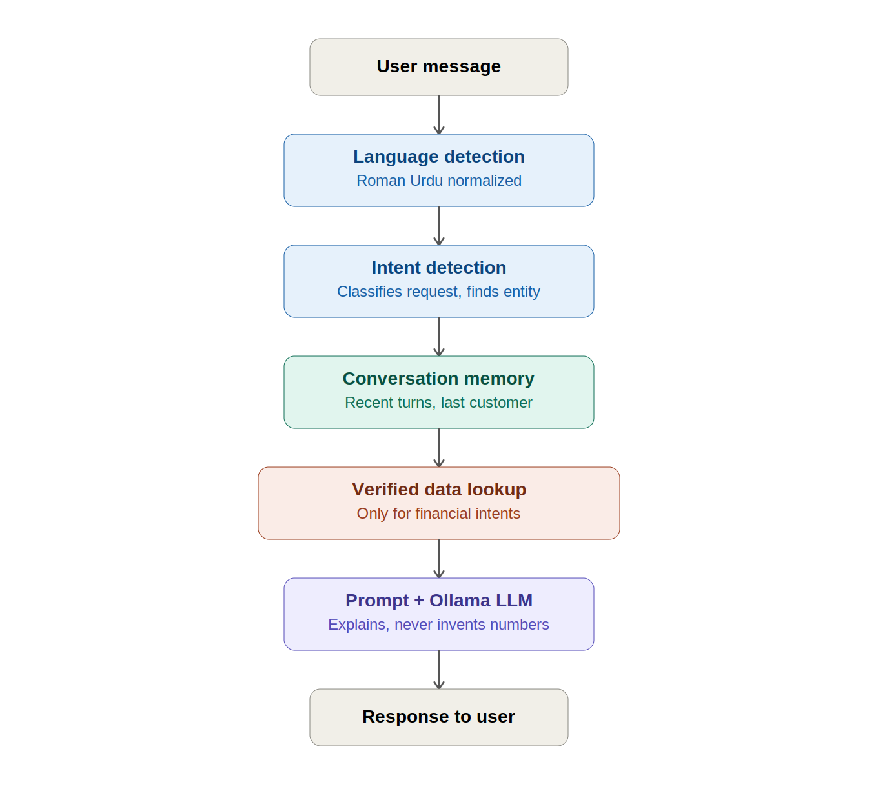

4.2 RAG Knowledge Base Pipeline
This diagram shows how source documents (FAQs and guides) are processed into a FAISS vector store and how user questions are matched against this store to provide verified context to the chatbot LLM.
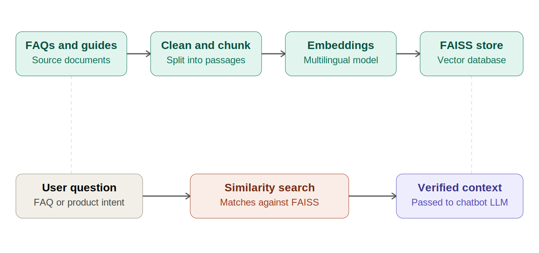

4.3 Chatbot Integration Architecture
This diagram shows how the React Chat UI connects to the Chatbot Service (/api/ai/chat), which routes requests to either the RAG Knowledge Base (in progress) or the Financial AI Module (pending connection).
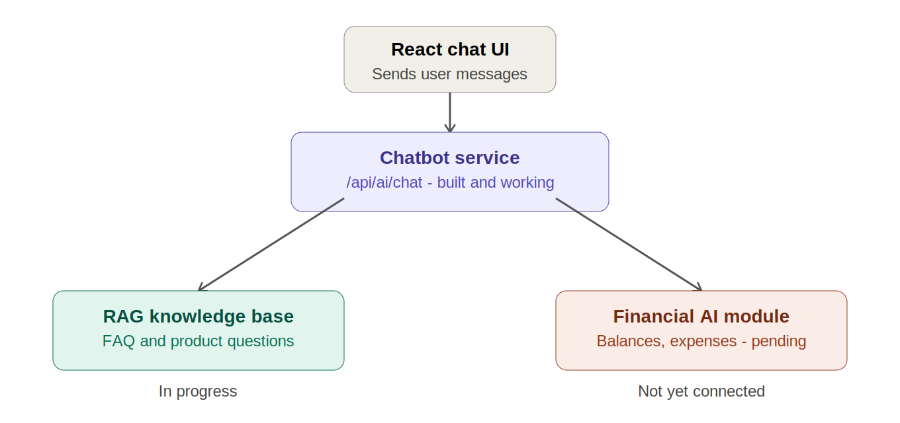

5. RAG Knowledge Base Development

RAG (Retrieval-Augmented Generation) lets the system retrieve relevant information first and then give the AI that information as context. This reduces unsupported answers and makes the assistant more grounded in approved application/business data.
Flow: User Question → Backend → Query/Embedding → Vector Store → Relevant Documents → LLM → Grounded Answer → User
• Collect approved documentation, FAQs and business rules
• Clean and split documents into useful chunks
• Generate embeddings and store them with metadata
• Retrieve the most relevant chunks for each question
• Send retrieved context to the model
• Add source/reference information where appropriate
• Evaluate retrieval accuracy and hallucinations

6. FAQ Assistant Implementation

• Maintain an approved FAQ dataset
• Search/retrieve the relevant answer context
• Return short and understandable answers
• Use a safe fallback when information is unavailable
• Log questions and answers for quality evaluation

7. AI Chatbot Integration

Architecture: Chat UI → Backend AI API → Authentication/Validation → RAG / Financial AI / Recommendation Services → LLM → Response
• Conversation history where needed
• User authentication and authorization
• RAG integration
• Financial-data access only for authorized users
• Timeout and error handling
• Usage and quality monitoring

8. Multilingual Support

• Allow language selection or detect the user's language
• Keep business logic and data processing language-independent
• Generate the final answer in the selected language
• Keep financial numbers, dates and currency values accurate
• Test the same questions across all supported languages

9. Financial AI Integration

Financial AI should analyze and explain application data. The backend remains the source of truth for calculations; the AI explains results and produces insights.
• Income and expense summaries
• Category-wise spending analysis
• Budget comparison
• Unusual spending detection
• Period-over-period comparisons
• Cash-flow summaries
• Plain-language financial explanations
• Actionable recommendations

10. Smart Insights & Recommendations

• Personalized recommendations: based on the user's own activity
• Related content: show information related to the current content/question
• Behavior-based recommendations: use meaningful usage patterns
• Smart financial insights: identify trends and areas needing attention
• Explainability: tell the user why an insight/recommendation was generated

11. User Engagement Implementation

• Personalized reminders or prompts
• Relevant recommendations
• Progress/activity summaries
• Helpful chatbot follow-ups
• Optional notifications based on user preferences
• Measure whether engagement features provide real user value

12. Development Milestones

# | Milestone | Main Deliverable
1 | Foundation | Architecture, model strategy, security & data requirements
2 | RAG | Ingestion, embeddings, retrieval & evaluation
3 | FAQ | Reliable FAQ/RAG answer workflow
4 | Chatbot | Conversational UI & backend AI integration
5 | Multilingual | Language handling & evaluation
6 | Financial AI | Deterministic analytics + AI explanations
7 | Insights | Smart insights & recommendation logic
8 | Engagement | Personalized AI engagement features
9 | Quality | Security, performance, accuracy & regression testing
10 | Scale | Monitoring, caching, cost control & production readiness

13. Module Ownership

Module | Owner | Responsibility
RAG Knowledge Base | Omesh Lakhani | Ingestion, retrieval and evaluation
FAQ Assistant | Omesh Lakhani | FAQ data and answer/fallback flow
AI Chatbot | Omesh Lakhani | Chat UI and AI backend integration
Multilingual | Omesh Lakhani | Language handling and testing
Financial AI | Omesh Lakhani | Financial analytics integration and explanations
Recommendations | Omesh Lakhani | Personalization and recommendation logic
Testing/Evaluation | Omesh Lakhani | AI test cases, datasets and regression
GitHub/DevOps | Omesh Lakhani | Branches, CI/CD, environments and deployment

14. Technical Dependencies & Blockers

• Model: hosted LLM or local model (Ollama-supported)
• RAG storage: vector database and embeddings
• Backend: FastAPI or existing backend API layer
• Data: clean documentation, FAQs and authorized application data
• Authentication: user identity and permissions
• Infrastructure: development, staging and production environments
• Cost/limits: token usage, latency, quotas and hosting cost
• Security: protect sensitive financial information and secrets
• Evaluation data: representative questions with expected answers

15. Testing & Evaluation Strategy

Test Area | Question | Approach
Functional | Does the feature work? | UI, API, auth, permissions and error testing
RAG Retrieval | Did it find the right context? | Known questions with expected relevant documents
Answer Accuracy | Is the answer correct? | Compare against approved expected answers
Hallucination | Does it invent information? | Unsupported questions and safe-fallback tests
Financial Accuracy | Are numbers correct? | Compare with deterministic backend calculations
Multilingual | Is meaning preserved? | Test terminology, meaning and financial values
Performance | Is it fast enough? | Measure response time and concurrent requests
Security | Is data protected? | Authorization, prompt-injection and sensitive-data tests
Regression | Did changes break old behavior? | Run fixed AI evaluation suite after changes

16. GitHub Development Workflow

• Create one feature branch per AI module (e.g. feature/rag, feature/financial-ai)
• Use small and meaningful commits
• Open a Pull Request for review
• Run automated tests before merging
• Require code review for production branches
• Merge only after tests and review pass
• Tag stable milestones/releases
• Never commit API keys or environment secrets

17. Scalable Long-Term AI Vision

The long-term goal is a modular AI platform where new AI capabilities can be added without rebuilding the whole application.
Target Architecture: Web/Mobile App → API Gateway → AI Orchestration Layer → {RAG, FAQ, Chatbot, Financial AI, Recommendations} → Model Layer → Data/Vector Stores → Monitoring & Evaluation
• Keep AI services modular
• Separate business logic from prompts
• Use RAG for controlled knowledge
• Keep deterministic calculations outside the LLM
• Support cloud and local model options where practical
• Use caching/asynchronous processing when useful
• Monitor quality, latency, errors and cost
• Version prompts, evaluation datasets and model configurations
• Protect user data through authentication and secure logging
• Design APIs so additional models can be introduced later

18. Overall Implementation Flow

Existing Application Data → Data Cleaning & Knowledge Preparation → RAG Knowledge Base + Financial Data Services → AI Orchestration/Backend → LLM → FAQ / Chatbot / Financial AI / Recommendations → Multilingual Response + Smart Insights → User Engagement → Monitoring + Testing + Continuous Improvement

19. Conclusion

The next phase moves the project from AI research and planning toward a structured, testable AI platform. RAG should be the core knowledge foundation, followed by the FAQ Assistant and Chatbot. Multilingual Support, Financial AI, Smart Insights, Recommendations and User Engagement can then build on the same AI service layer. This reduces duplication, improves maintainability and makes future AI features easier to add.

— End of Document —

